Diabetes Prediction using Machine Learning

Haya Khaled
Computer Department,
Arab Academy For Science and
Technology and Maritime
Transport,
Alexandria, Egypt
Nada Omar
Computer Department,
Arab Academy For Science and
Technology and Maritime
Transport,
Alexandria, Egypt
Farah Anany
Computer Department,
Arab Academy For Science and
Technology and Maritime
Transport,
Alexandria, Egypt

Abstract: This study explores the application of machine learning algorithms to predict diabetes using the Pima Indians Diabetes Database. We compare the performance of various models, including artificial neural networks (ANN), k-means clustering, Naive Bayes, and decision trees. The models are evaluated using metrics such as accuracy, precision, recall, and F1-score. Our results demonstrate the potential of machine learning in medical diagnostics and highlight the importance of data quality and feature selection.
Introduction
The prediction of diabetes using machine learning techniques has become an essential task in medical informatics due to the rising prevalence of diabetes globally. Early detection of diabetes can significantly improve patient outcomes by enabling timely interventions. In this work, we utilize the Pima Indians Diabetes Database to build and evaluate machine learning models that predict the likelihood of diabetes in individuals based on specific health metrics.

Ease of Use
- Context

Diabetes is a chronic disease that occurs either when the pancreas does not produce enough insulin or when the body cannot effectively use the insulin it produces. The increasing incidence of diabetes worldwide necessitates the development of robust predictive models to aid in early diagnosis and management. Machine learning offers powerful tools to analyze medical data and uncover patterns that can predict diabetes onset.

Hurdles

Several challenges are associated with this task. Ensuring the dataset is clean and balanced is crucial for building reliable models. Identifying the most predictive features among the available data points is essential for model accuracy. Medical professionals require models that are not only accurate but also interpretable to trust and act upon their predictions. Additionally, choosing appropriate metrics for performance evaluation is important to meaningfully assess the model's effectiveness.
- Objective
This study aims to develop machine learning models that accurately predict diabetes using the Pima Indians Diabetes Database. The focus is on comparing the performance of ANN, k-means clustering, Naive Bayes, and decision trees. By doing so, we intend to determine which model offers the best trade-off between accuracy and interpretability.

- Objective
This study aims to develop machine learning models that accurately predict diabetes using the Pima Indians Diabetes Database. The focus is on comparing the performance of ANN, k-means clustering, Naive Bayes, and decision trees. By doing so, we intend to determine which model offers the best trade-off between accuracy and interpretability.

Related Work
- Overview
Previous research in the domain of diabetes prediction using machine learning has explored a wide array of algorithms, each with its own strengths and weaknesses. Early studies often employed logistic regression and decision trees due to their simplicity and interpretability. These models provided a solid foundation for initial predictive efforts but were limited in their ability to capture complex patterns in data

- Related Background Decision Trees
offer an intuitive model that splits the data into branches based on feature values, leading to a tree-like structure of decisions. They are particularly useful for their interpretability, as each decision path can be traced back to the input features, making it easy to understand how predictions are made. In the context of diabetes prediction, decision trees can handle both numerical and categorical data and provide insights into feature importance. However, decision trees are prone to overfitting, especially with small datasets or when they are very deep.

- Artificial Neural Networks (ANNs) Related Background
have been increasingly applied in recent years due to their ability to model complex, non-linear relationships. ANNs consist of layers of interconnected nodes (neurons), each performing a weighted sum of inputs followed by a non-linear activation function. For diabetes prediction, ANNs can learn intricate patterns in the data that traditional models might miss. However, they require large amounts of data and computational resources, and they lack interpretability compared to simpler models.

- Naive Bayes Related Background
is another simple yet effective model based on Bayes' theorem with an assumption of independence between predictors. Despite its simplicity, Naive Bayes can perform surprisingly well in many classification tasks, including diabetes prediction. It is computationally efficient and works well with small datasets, but its assumption of feature independence often doesn't hold in real-world data, potentially limiting its performance.

In this study, we build on these previous efforts by conducting a comparative analysis of different machine learning models using the same dataset. We include models with varying levels of complexity and interpretability to provide a comprehensive evaluation of their performance in predicting diabetes. This approach not only highlights the strengths and weaknesses of each model but also offers insights into their practical applications in medical diagnostics.
- Proposed Model
We propose a comprehensive machine learning framework designed to predict diabetes using the Pima Indians Diabetes Database. This framework includes several critical steps: data preprocessing, feature selection, model training, and evaluation. The primary goal is to assess the performance of different machine learning models and identify the most effective approach for diabetes prediction. The models considered in this study are Artificial Neural Networks (ANN), k-means clustering, Naive Bayes, and decision trees. Each model offers unique advantages and challenges, and their comparative analysis provides a thorough understanding of their capabilities and limitations.

ANN Architectural overview
An architectural overview of an artificial neural network (ANN) provides a concise depiction of its structure and operation. We used PyTorch after splitting the data to testing and training. Then we converted the data to PyTorch tensors. Afterwards, we built the artificial neural network model. This model is a feedforward neural network comprising two hidden layers and an output layer. When data is forwarded through the network, it traverses each layer sequentially. Following each hidden layer, a Rectified Linear Unit (ReLU) activation function is applied to introduce non-linearity. Then, we worked on Model Initialization, Loss Function, and Optimizer. An instance of the defined model is created. Cross-entropy loss is chosen as the loss function, and Adam optimizer is used for optimizing the model parameters. The trained model was evaluated on the testing set. Predictions were made on each data point in the testing set, and the predicted class labels were stored. Then, we saved and loaded the model and created a confusion matrix. After that, we were able to test this model on new data and figure out whether the person has diabetes or not.he confusion matrix shows that the model achieved 144 true positives, 33 true negatives, 13 false positives, and 41 false negatives on the test set. The accuracy score of approximately 76.62% indicates the overall correctness of the model's predictions.

Decision tree's Architectural overview
A decision tree's architectural overview sketches its structure and function succinctly. It showcases the hierarchy of decision and leaf nodes, representing conditions and outcomes, respectively. This depiction clarifies how input features guide decision-making from the root to the leaves, using criteria like Gini impurity or information gain. Understanding this architecture aids in interpreting decision logic transparently and refining the model for better predictions.

E.Naive bayes Architectural overview
Naive Bayes is a simple, efficient probabilistic classifier that assumes feature independence. It calculates class probabilities and predicts the most probable class based on Bayes' theorem. Despite its independence assumption, it works well for tasks like text classification and spam detection due to its efficiency and scalability.

experimental work

Dataset
The data set was obtained from kaggle and consists of 768 rows and 9 columns . Predictor variables includes the number of pregnancies the patient has had, their BMI, insulin level, age, and so on.
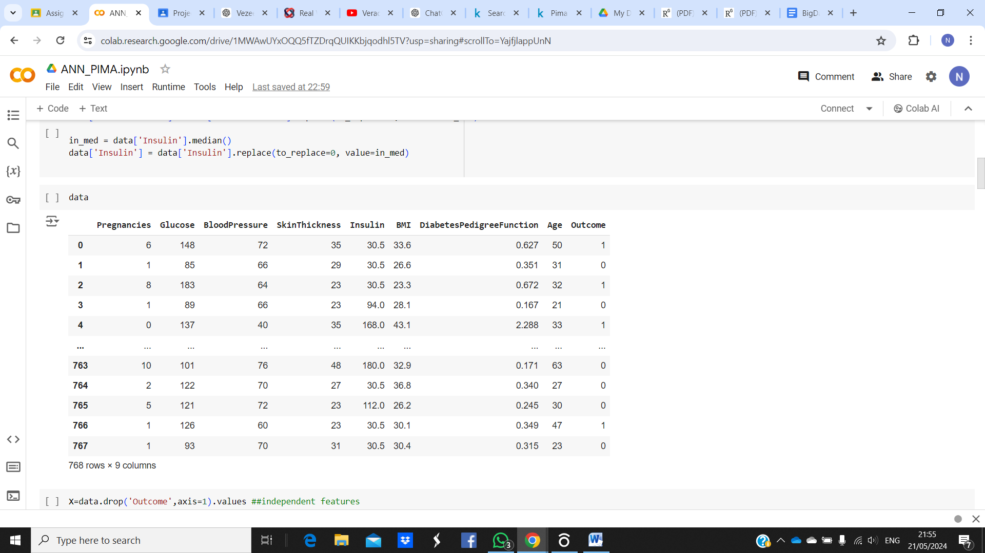

DATA PREPROCESSING AND NORMALZIATION
The provided code initiates by loading a diabetes dataset and conducts comprehensive preprocessing steps to ensure data quality and suitability for modelling. Missing values are replaced with median values to maintain data integrity, and feature correlations are visualized using a heatmap to understand variable relationships. Various visualization techniques, including histograms and pair plots, are employed to explore data distribution and identify potential patterns. Outliers are detected using box plots and histograms, though no explicit handling is performed. Standard scaling normalizes numerical features, and the dataset is split into training and testing sets for model evaluation. A K-Nearest Neighbors (KNN) classifier is then trained and evaluated on the preprocessed data, with performance metrics analyzed through a confusion matrix and classification report. Overall, these preprocessing steps aim to enhance the dataset's quality and facilitate accurate model training and evaluation for diabetes prediction.

DATA AFTER NORMALIZATION
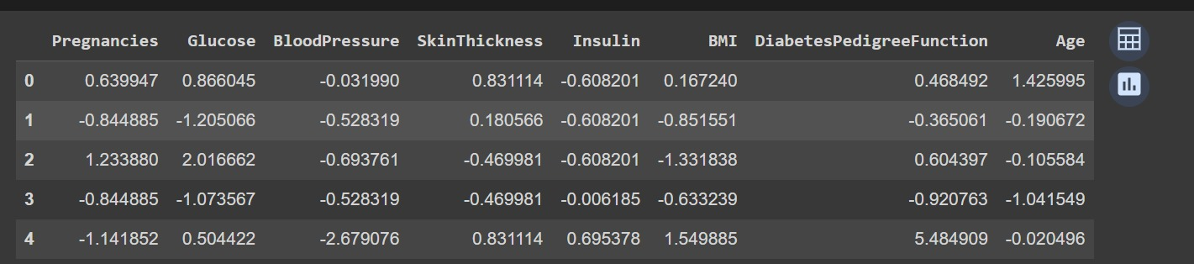

C.Results
[1] Naïve Bayes accuracy
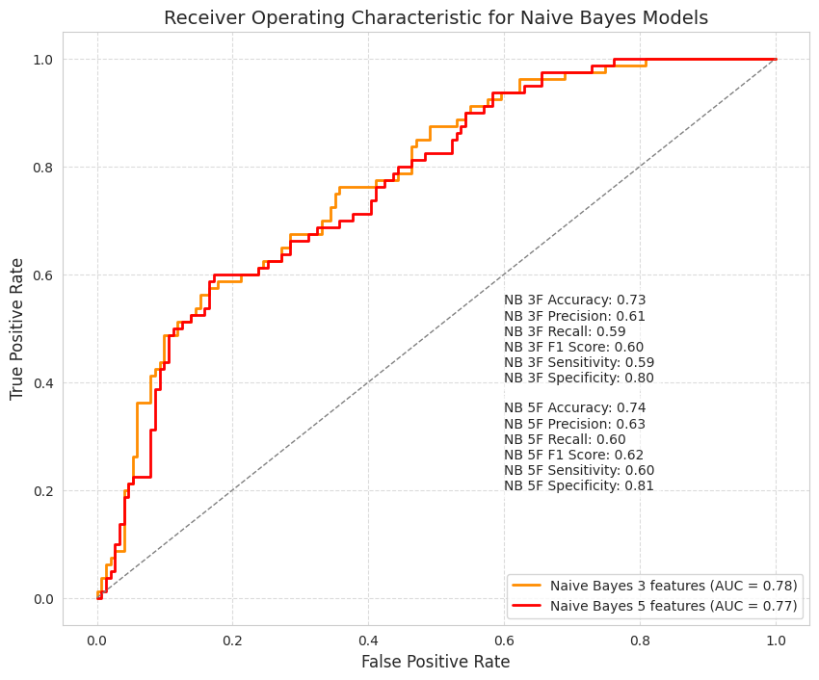

[2] Decision trees accuracy
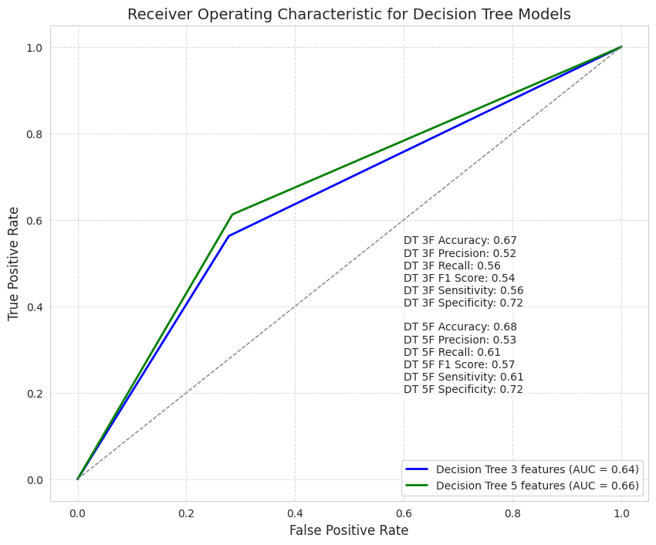

[3] ANN accuracy
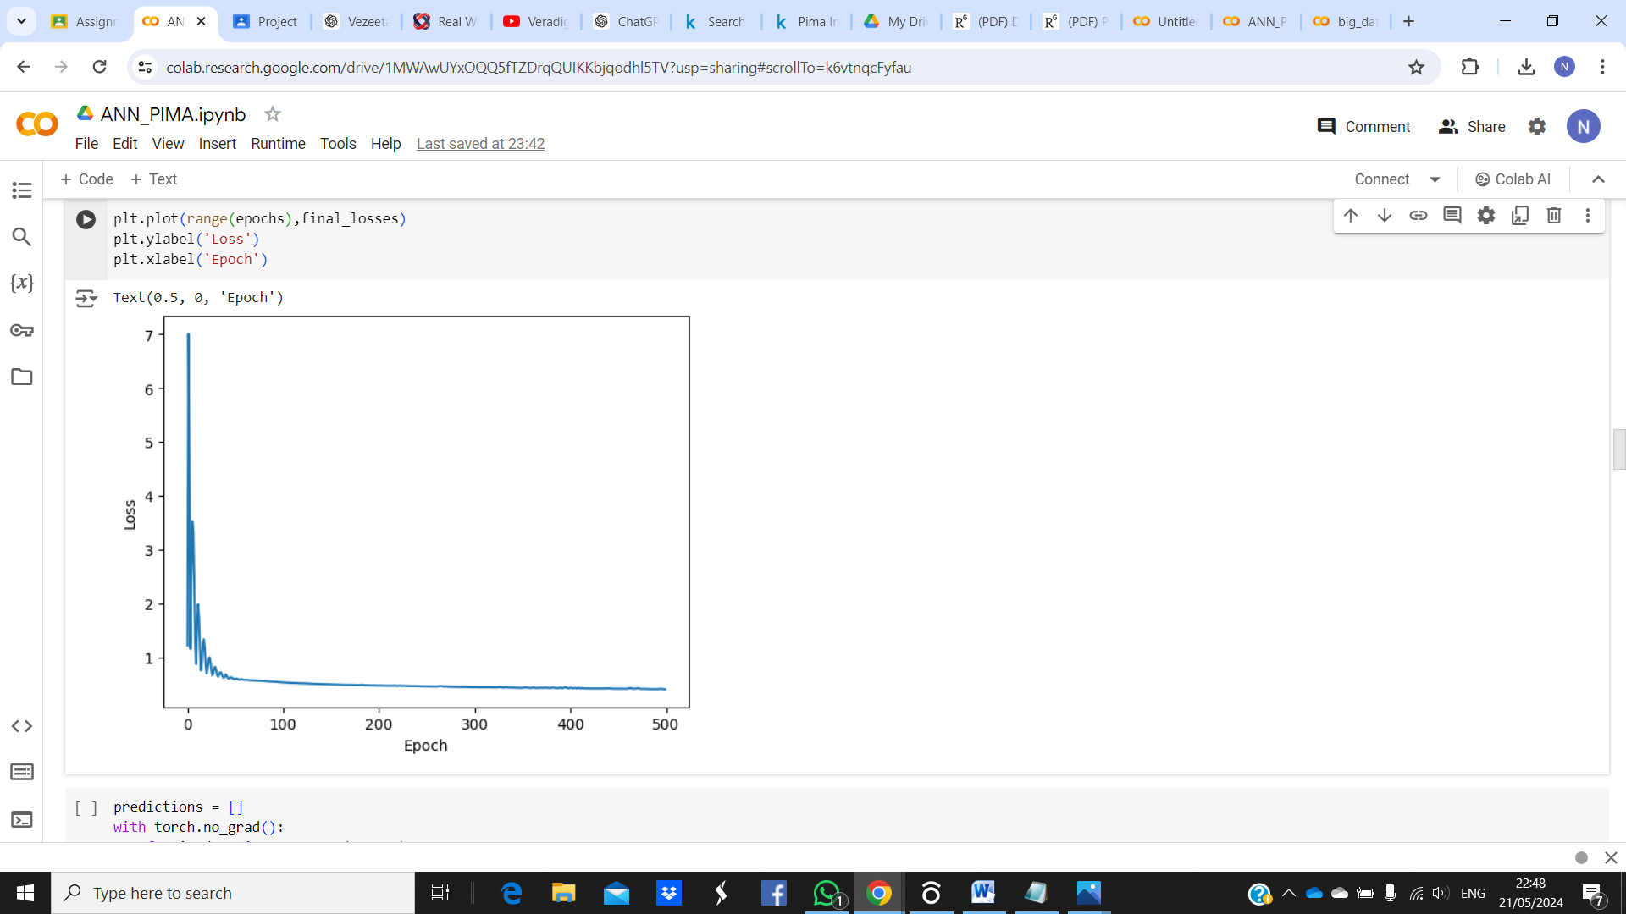
[4] KNN accuracy

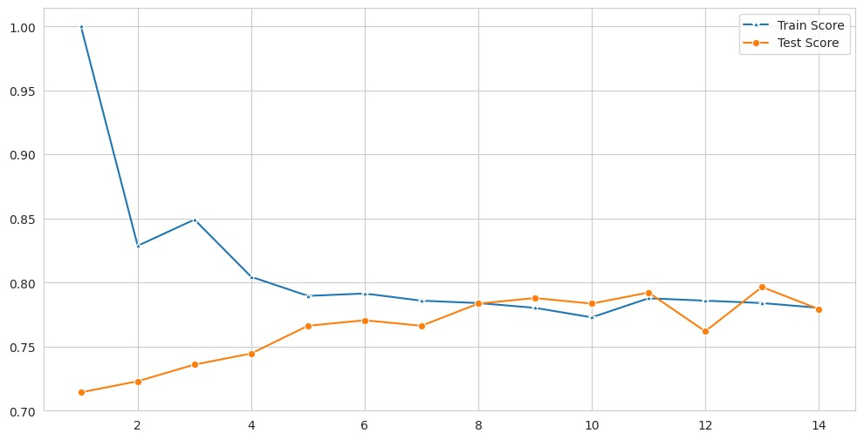
[5] ANN Accuracy
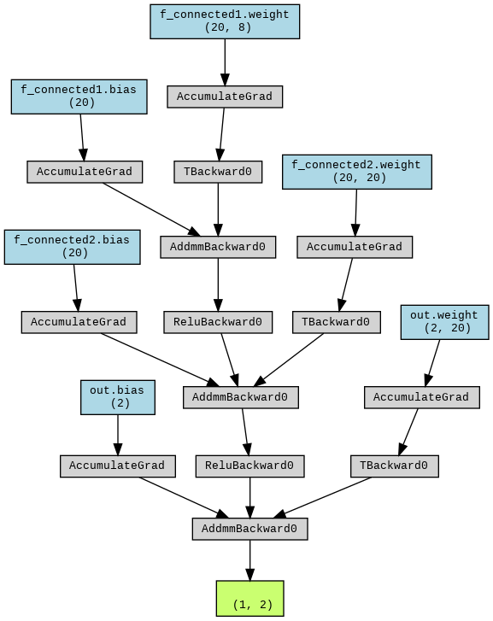

D.Confusion Metrics
[1] Naïve Bayes
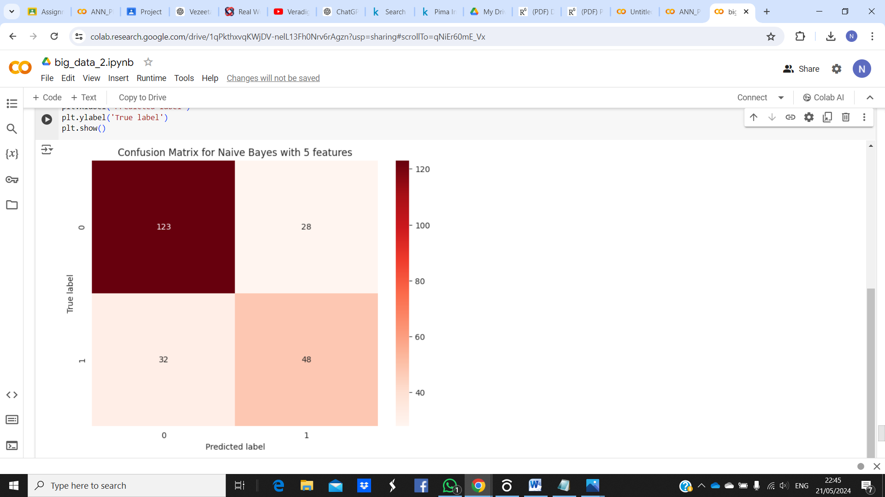
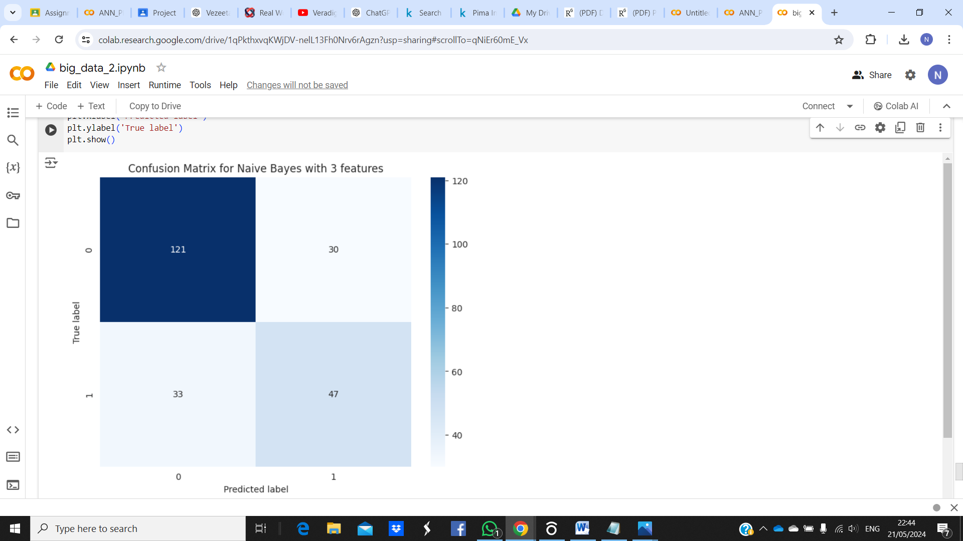
[2] ANN
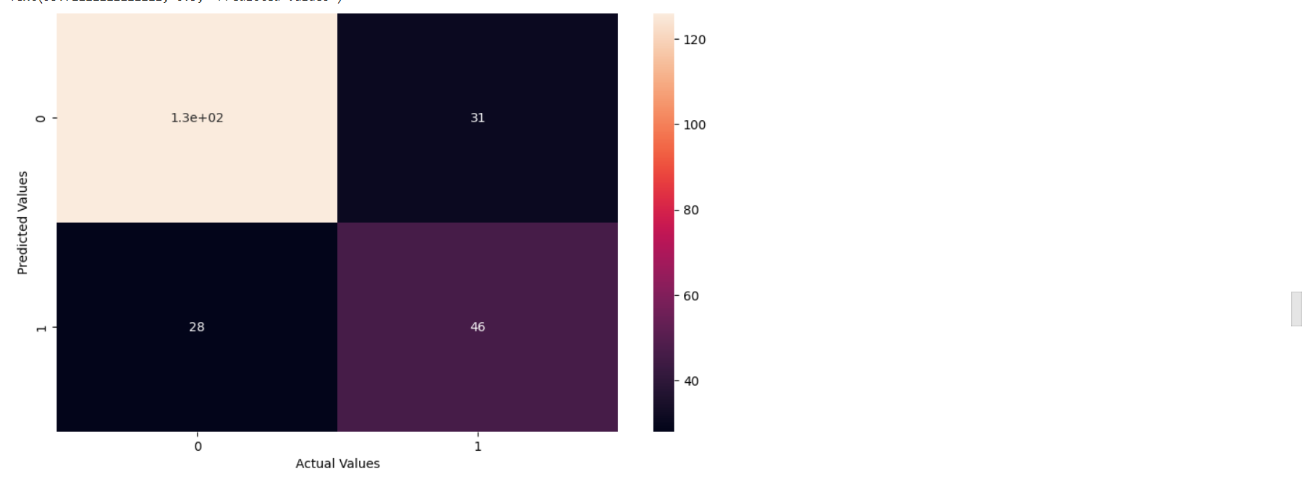

III . CONCLUSION
In conclusion, both decision trees and Naive Bayes offer valuable insights and predictive capabilities when applied to the diabetes dataset. Decision trees provide a transparent, interpretable model that can capture complex relationships within the data, aiding in understanding the factors influencing diabetes diagnosis. On the other hand, Naive Bayes offers a simple yet efficient probabilistic approach that can handle large datasets and is particularly effective when feature independence assumptions hold. Combining these methods could provide a comprehensive understanding of the dataset, leveraging the strengths of each approach for more accurate predictions and actionable insights in diabetes diagnosis and management.

References

[1] Global Report on Diabetes, 2016”. Available at: https://apps.who.int/iris/bitstream/handle/10665/204871/9789241565257_eng.pdf;jsessionid=2BC28035503CFAFF295E70CFB4A0E1DF?Sequence=1

[2] “Diabetes: Asia's 'silent killer'”, November 14, 2013”. Available at:www.bbc.com/news/world-asia-24740288.

[3] Mathers CD, Loncar D. Projections of global mortality and burdenof disease from 2002 to 2030.2015;3(11). https://doi.org/10.1371/journal.pmed.0030442.

[4]. World Health Organization (2013) , ‘Global action plan for the prevention and control of NCDs 2013-2020’, Available at https://apps.who.int/iris/bitstream/handle/10665/94384/9789241506236_eng.pdf;jsessionid=5A344A4B152EABE6C021C9A7EEE444C8?sequence=1 (Accessed 24 February, 2021)

[5]. Schulz, L.O., Bennett, P.H., Ravussin, E., Kidd, J.R., Kidd, K.K., Esparza, J. and Valencia, M.E. (2006). 'Effects of Traditional and Western Environments on Prevalence of Type 2 Diabetes in Pima Indians in Mexico and the US', Diabetes care, vol. 29, no. 8, pp. 1866-71.

[6]. Smith, J.W., Everhart, J.E., Dickson, W.C., Knowler, WC and Johannes, R.S. (1988). 'Using the ADAP Learning Algorithm to Forecast the Onset of Diabetes Mellitus'. Proceedings of the Annual Symposium on Computer Application in Medical Care pp. 261–265.

“Global Report on Diabetes, 2016”. Available at: https://apps.who.int/
iris/bitstream/handle/10665/204871/9789241565257_eng.pdf;
jsessionid=2BC28035503CFAFF295E70CFB4A0E1DF?Sequence=1.
2. “Diabetes: Asia's 'silent killer'”, November 14, 2013”. Available at:
www.bbc.com/news/world-asia-24740288.
3. Mathers CD, Loncar D. Projections of global mortality and burden
of disease from 2002 to 2030. 2015;3(11). https://doi.org/10.1371/
journal.pmed.0030442.
4. Swapna G, Vinayakumar R, Soman KP. Diabetes detection using
deep learning algorithms. ICT Express. 2018;4(4):243–6. https://
doi.org/10.1016/j.icte.2018.10.005. Elsevier B.V.
5. Wu H, et al. Type 2 diabetes mellitus prediction model based on
data mining. Informatics in Medicine Unlocked. 2018;10:100–7.
https://doi.org/10.1016/j.imu.2017.12.006. Elsevier Ltd.
6. Emerging T, Factors R. Diabetes mellitus , fasting blood glucose
concentration , and risk of vascular disease : a collaborative meta-
analysis of 102 prospective studies. The Lancet. 2010;375(9733):
2215–22. https://doi.org/10.1016/S0140-6736(10)60484-9
Elsevier Lt
“Global Report on Diabetes, 2016”. Available at: https://apps.who.int/
iris/bitstream/handle/10665/204871/9789241565257_eng.pdf;
jsessionid=2BC28035503CFAFF295E70CFB4A0E1DF?Sequence=1.
2. “Diabetes: Asia's 'silent killer'”, November 14, 2013”. Available at:
www.bbc.com/news/world-asia-24740288.
3. Mathers CD, Loncar D. Projections of global mortality and burden
of disease from 2002 to 2030. 2015;3(11). https://doi.org/10.1371/
journal.pmed.0030442.
4. Swapna G, Vinayakumar R, Soman KP. Diabetes detection using
deep learning algorithms. ICT Express. 2018;4(4):243–6. https://
doi.org/10.1016/j.icte.2018.10.005. Elsevier B.V.
5. Wu H, et al. Type 2 diabetes mellitus prediction model based on
data mining. Informatics in Medicine Unlocked. 2018;10:100–7.
https://doi.org/10.1016/j.imu.2017.12.006. Elsevier Ltd.
6. Emerging T, Factors R. Diabetes mellitus , fasting blood glucose
concentration , and risk of vascular disease : a collaborative meta-
analysis of 102 prospective studies. The Lancet. 2010;375(9733):
2215–22. https://doi.org/10.1016/S0140-6736(10)60484-9
Elsevier Lt
“Global Report on Diabetes, 2016”. Available at: https://apps.who.int/
iris/bitstream/handle/10665/204871/9789241565257_eng.pdf;
jsessionid=2BC28035503CFAFF295E70CFB4A0E1DF?Sequence=1.
2. “Diabetes: Asia's 'silent killer'”, November 14, 2013”. Available at:
www.bbc.com/news/world-asia-24740288.
3. Mathers CD, Loncar D. Projections of global mortality and burden
of disease from 2002 to 2030. 2015;3(11). https://doi.org/10.1371/
journal.pmed.0030442.
4. Swapna G, Vinayakumar R, Soman KP. Diabetes detection using
deep learning algorithms. ICT Express. 2018;4(4):243–6. https://
doi.org/10.1016/j.icte.2018.10.005. Elsevier B.V.
5. Wu H, et al. Type 2 diabetes mellitus prediction model based on
data mining. Informatics in Medicine Unlocked. 2018;10:100–7.
https://doi.org/10.1016/j.imu.2017.12.006. Elsevier Ltd.
6. Emerging T, Factors R. Diabetes mellitus , fasting blood glucose
concentration , and risk of vascular disease : a collaborative meta-
analysis of 102 prospective studies. The Lancet. 2010;375(9733):
2215–22. https://doi.org/10.1016/S0140-6736(10)60484-9
Elsevier Lt

